Linux Code Generation Target
for Simulink Embedded Real-Time (ERT)
Czech Technical University in Prague, FEE, Department of Control Engineering
http://dce.fel.cvut.cz/
Linux ERT target for MathWorks' Simulink Embedded Coder® allows to compile a model of designed control system to the C-code and combine it with target specific support functions.
The resulting executable/controller can be run in real-time on the target Linux system.
The running dynamic system can be augmented via tunable block parameters
in the Simulink model and data can be acquired and visualized with Simulink scopes.
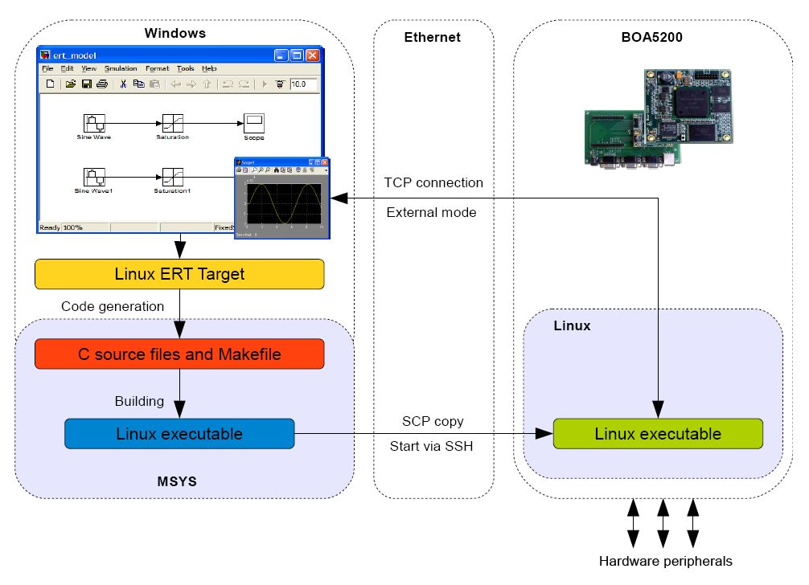
Linux ERT target heavily uses real-time capabilities of real-time variant of the Linux kernel. The resulting control system supports sampling frequencies up to 20 kHz.
With carefully selected x86 or embedded hardware, such system can run for months without missing a single deadline (see OSADL Quality Assurance Farm: http://www.osadl.org/QA-Farm-Realtime.qa-farm-about.0.html).
The target includes Simulink blocks for communication with CANopen protocol and for accessing multifunction I/O cards.
Further information:
- Lintarget project at Source Forge:
http://lintarget.sourceforge.net/
project download area contains Linux ERT target and a CANopen blockset.
- Linux ERT target source code:
http://rtime.felk.cvut.cz/gitweb/ert_linux.git
version updated for real-time and native GNU/Linux host/target system setup
- Humusoft MF624 I/O card blockset:
http://rtime.felk.cvut.cz/gitweb/mf624-simulink.git
initial version of blockset supporting analog and digital input/output, IRC, PWM
and PWM measurement for MF624 cards.
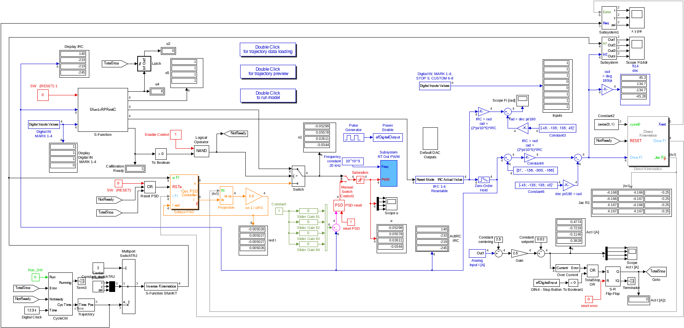
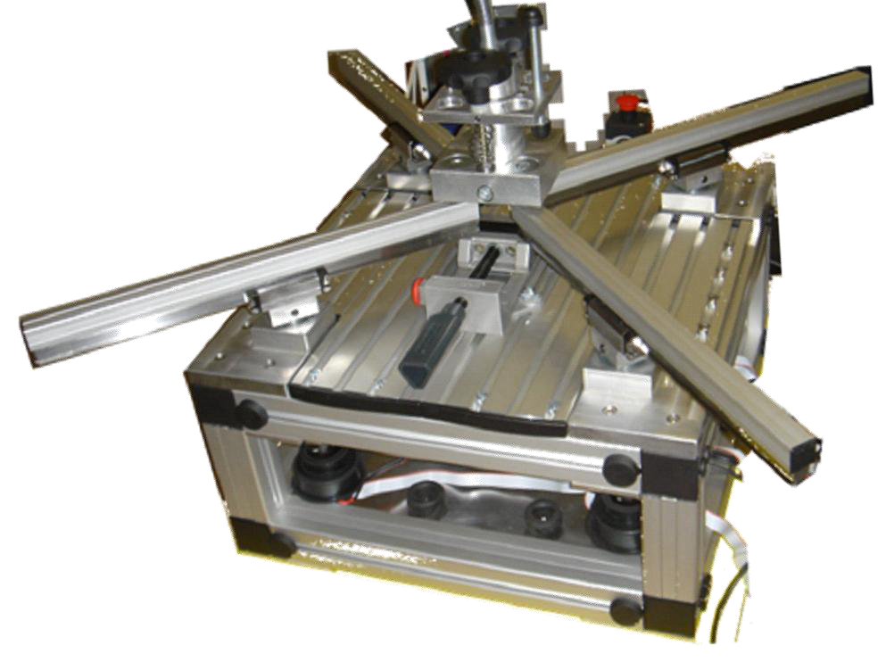
Detailed information about parallel kinematic robot control and predictive control
in general can be found at http://as.utia.cz/asc/GPCweb/GPC.php.cs.utf8
at Adaptive Systems Department http://as.utia.cz/asc/, http://www.utia.cas.cz/AS
More information about ERT Linux target is available
at project page: http://lintarget.sourceforge.net/

Example of ERT Linux Target
Realization of the control for parallel kinematic system (Moving Slide)
developed at the Department of Adaptive Systems
Institute of Information Theory and Automation
Academy of Sciences of the Czech Republic

